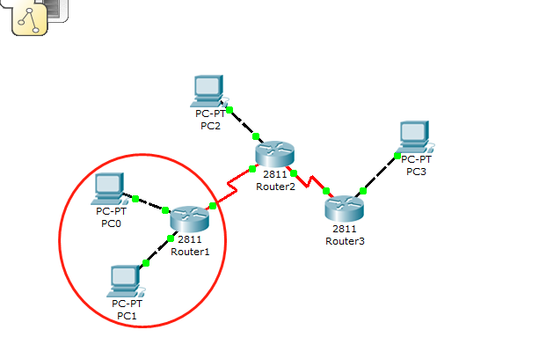

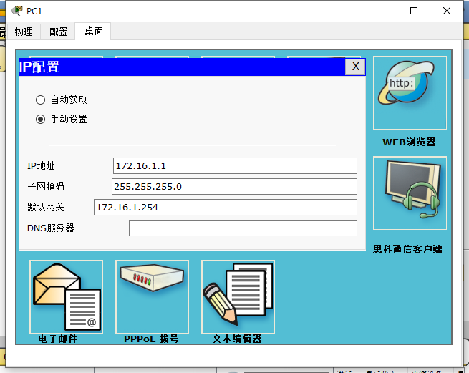

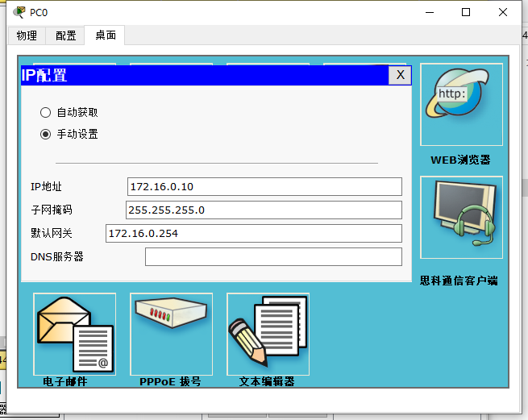

Router1配置信息

Router1>enable

Router1#show running-config

!

hostname Router1

interface Loopback 0

ip address 1.1.1.1 255.255.255.252

!

interface FastEthernet0/0

ip address 172.16.0.254 255.255.255.0

duplex auto

speed auto

!

interface FastEthernet0/1

ip address 172.16.1.254 255.255.255.0

duplex auto

speed auto

!

interface Serial0/3/0

ip address 10.1.1.1 255.255.255.252

clock rate 125000

!

router ospf 1

router-id 1.1.1.1

log-adjacency-changes

network 1.1.1.0 0.0.0.3 area 0

network 172.16.0.0 0.0.0.255 area 0

network 172.16.1.0 0.0.0.255 area 0

network 10.1.1.0 0.0.0.3 area 0

!

end

Router1-接口-配置信息

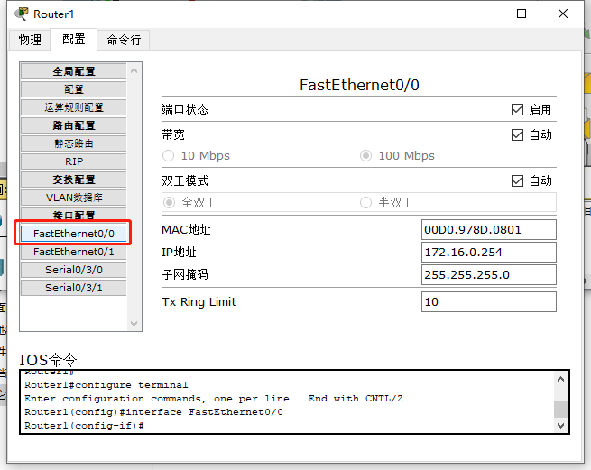

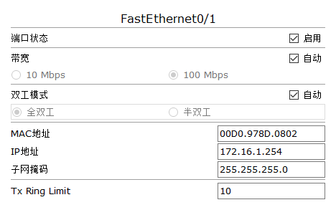

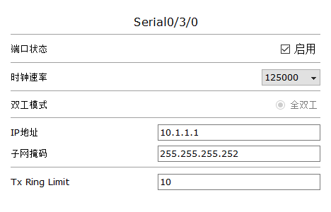

Router1本地回环接口配置过程：

Router1#configure terminal

Router1(config)#interface Loopback0

Router1(config-if)ip address 1.1.1.1 255.255.255.252

Router1-OSPF路由配置过程：

Router1#configure terminal

Router1(config)#router ospf 1

Router1(config-router)#router-id 1.1.1.1

Router1(config-router)#network 1.1.1.0 0.0.0.3 area 0

Router1(config-router)#network 172.16.0.0 0.0.0.255 area 0

Router1(config-router)#network 172.16.1.0 0.0.0.255 area 0

Router1(config-router)#network 10.1.1.0 0.0.0.3 area 0

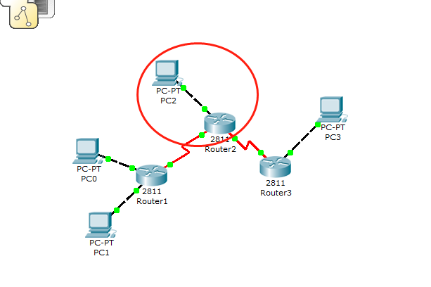

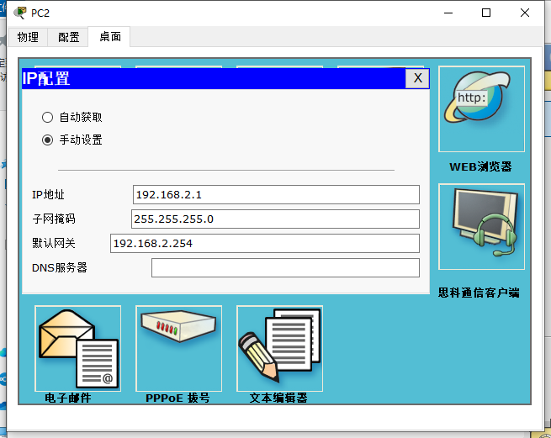

Router2配置信息

Router2>enable

Router2#configure terminal

Router2#do show running

!

hostname Router2

interface Loopback0

ip address 1.1.1.2 255.255.255.252

!

interface FastEthernet0/0

ip address 192.168.2.254 255.255.255.0

duplex auto

speed auto

!

interface Serial0/3/0

ip address 10.1.1.2 255.255.255.252

clock rate 125000

!

interface Serial0/3/1

ip address 11.1.1.2 255.255.255.252

clock rate 125000

!

router ospf 1

router-id 1.1.1.2

log-adjacency-changes

redistribute static subnets

network 1.1.1.0 0.0.0.3 area 0

network 192.168.2.0 0.0.0.255 area 0

network 10.1.1.0 0.0.0.3 area 0

!

ip classless

ip route 222.1.3.0 255.255.255.0 11.1.1.1

End

Router2-接口-配置信息

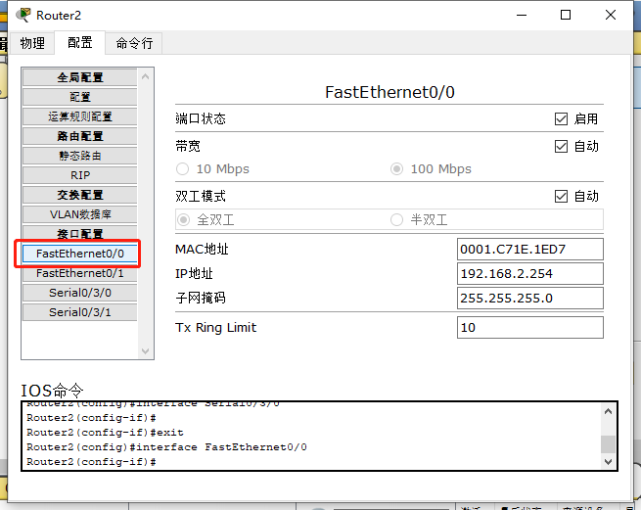

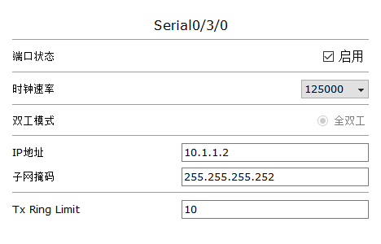

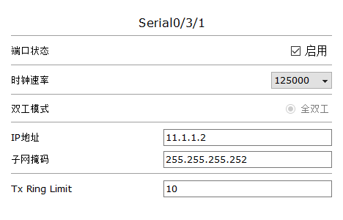

Router2-本地回环接口-配置过程

Router2>enable

Router2#configure terminal

Router2(config)# interface Loopback0

Router2(config-if)# ip address 1.1.1.2 255.255.255.252

Router2-OSPF路由-配置过程

Router2#configure terminal

Router2(config)#router ospf 1

Router2(config-router)#router-id 1.1.1.2

Router2(config-router)#redistribute static subnets

Router2(config-router)#network 1.1.1.0 0.0.0.3 area 0

Router2(config-router)#network 192.168.2.0 0.0.0.255 area 0

Router2(config-router)#network 10.1.1.0 0.0.0.3 area 0

Router2-静态路由-配置过程

Router2(config)#ip route 222.1.3.0 255.255.255.0 11.1.1.1

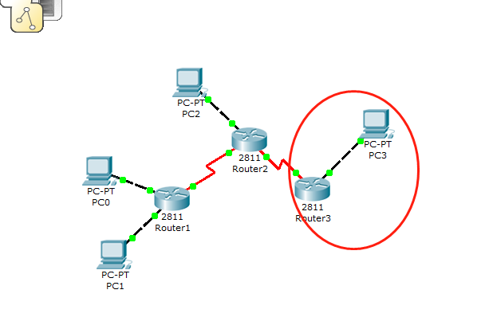

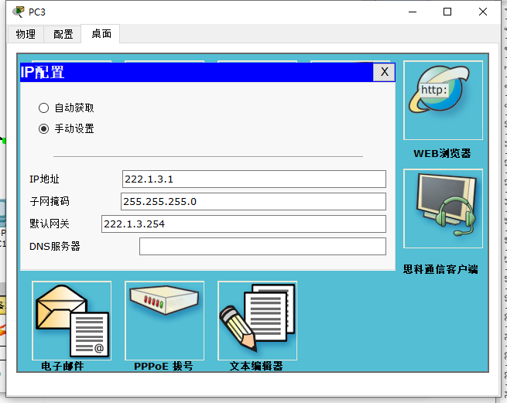

Router3配置信息

Router3>enable

Router3#show running-config

!

hostname Router3

!

interface FastEthernet0/0

ip address 222.1.3.254 255.255.255.0

duplex auto

speed auto

!

interface Serial0/3/0

ip address 11.1.1.1 255.255.255.252

clock rate 125000

interface Serial0/3/1

ip address 12.0.0.2 255.255.255.252

clock rate 125000

!

interface Vlan1

no ip address

shutdown

!

ip classless

ip route 192.168.2.0 255.255.255.0 11.1.1.2

ip route 172.16.0.0 255.255.255.0 11.1.1.2

ip route 0.0.0.0 0.0.0.0 12.0.0.1

!

End

Router3接口配置信息

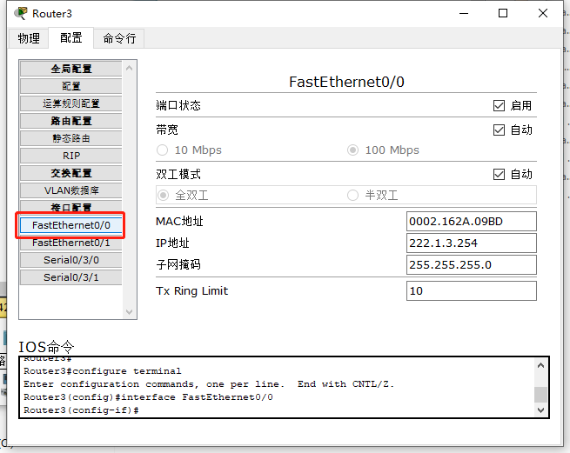

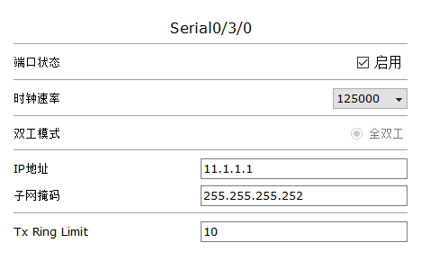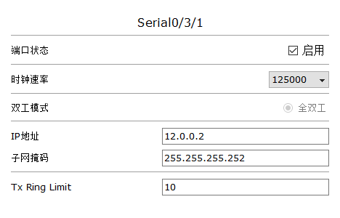

Router3-静态路由-配置信息

Router3>enable

Router3#configure terminal

Router3(config)#ip route 192.168.2.0 255.255.255.0 11.1.1.2

Router3(config)#ip route 172.16.0.0 255.255.255.0 11.1.1.2

Router3(config)#ip route 0.0.0.0 0.0.0.0 12.0.0.1

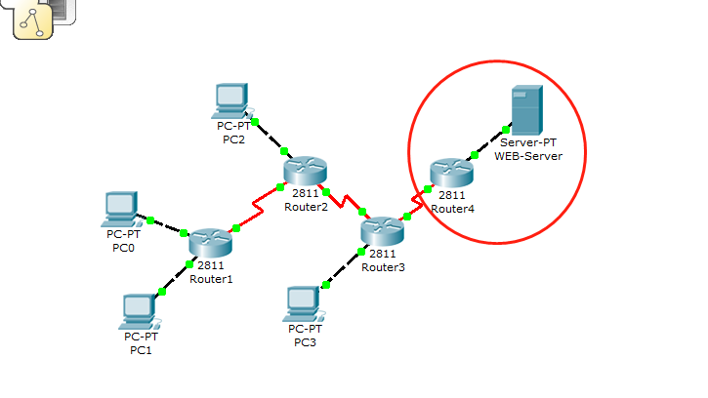

Router4配置信息

Router4#show run

!

hostname Router4

!

interface FastEthernet0/0

ip address 10.9.20.1 255.255.255.0

ip nat outside

duplex auto

speed auto

!

interface Serial0/3/0

ip address 12.0.0.1 255.255.255.252

ip nat inside

!

ip nat pool Lab02 10.9.20.2 10.9.20.8 netmask 255.255.255.0

ip nat inside source list 11 pool Lab02

ip nat inside source static 172.16.0.1 10.9.20.5

ip nat inside source static 172.16.0.10 10.9.20.5

ip classless

ip route 172.16.0.0 255.255.255.0 12.0.0.2

ip route 222.1.3.0 255.255.255.0 12.0.0.2

ip route 192.168.2.0 255.255.255.0 12.0.0.2

!

access-list 11 permit 172.16.1.0 0.0.0.255

access-list 11 permit 192.168.2.0 0.0.0.255

!

line con 0

line vty 0 4

login

!

End

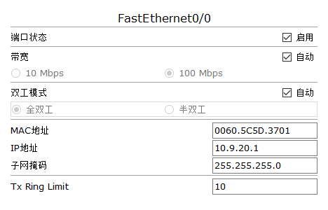

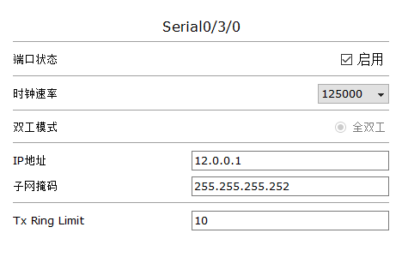

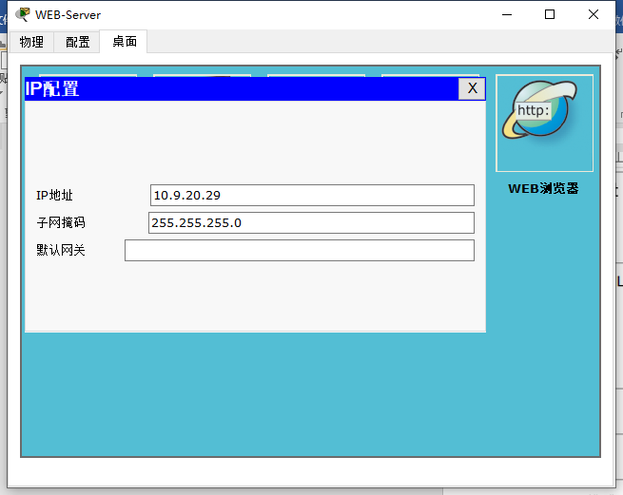

Router4-NAT-配置信息

Router4(config)# interface FastEthernet0/0

Router4(config-if)# ip address 10.9.20.1 255.255.255.0

Router4(config-if)# ip nat outside

!

Router4(config)#interface Serial0/3/0

Router4(config-if)# ip address 12.0.0.1 255.255.255.252

Router4(config-if)# ip nat inside

!

Router4(config)#ip nat pool Lab02 10.9.20.2 10.9.20.8 netmask 255.255.255.0

Router4(config)#ip nat inside source list 11 pool Lab02

Router4(config)#ip nat inside source static 172.16.0.1 10.9.20.5

Router4(config)#ip nat inside source static 172.16.0.10 10.9.20.5

!

Router4(config)#access-list 11 permit 172.16.1.0 0.0.0.255

Router4(config)#access-list 11 permit 192.168.2.0 0.0.0.255

Router4-静态路由-配置信息

Router4(config)#ip route 172.16.0.0 255.255.255.0 12.0.0.2

Router4(config)#ip route 222.1.3.0 255.255.255.0 12.0.0.2

Router4(config)#ip route 192.168.2.0 255.255.255.0 12.0.0.2